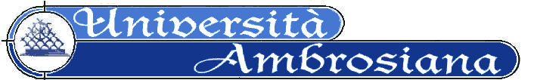

MEDICAL EDUCATION DEPT.
The European School of Medicine
The Milan School of Medicine

CERTIFICATE
in
PERSON CENTERED MEDICINE AND PERSON CENTERED CLINICAL METHOD©®
and
MASTER TEACHER CERTIFICATE
in
PERSON CENTERED MEDICINE TEACHING

INTRODUCTION AND CONTACTS

PROGRAM

APPLICATION FORM FOR ADMISSION

Copyright Università Ambrosiana-2009

